PT 8605
AES/EBU Audio Generator

The PT 8605 AES/EBU Audio Generator can be installed in the PT 5210 VariTime™ Digital Sync generator.

Packing list:
Check that the PT 8605 option package contains the following items:
 | Description: | Item | Quantity
 | Nut for BNC Connector | 2422 034 17419 | 1
 | Lockwasher for BNC Connector | 2422 034 17421 | 1
 | Pan Head Screw M3x6 | 2522 178 31058 | 10
 | Curved Spring Washer | 2522 728 04003 | 2
 | Ribbon Cable with micro 20 pole connectors | 4008 105 04030 | 1
 | AES/EBU Audio | 4008 109 83260 | 1

The system is “plug and play” meaning that when the unit is mounted no configuration is needed in order to enable the PT 8605.

Installation procedure:
- Open the PT 5210 by removing the top cover.
- Remove the plastic blind from the back panel for the BNC and XLR connectors marked AES/EBU audio.
- When the PT 8606 SDI Genlock module is installed this should be removed. Remove the screws holding the module and the lockwashers and nuts on the BNC connectors. Remove the hexagonal spacers and the distance washers below the hexagonal spacers.
- Install the PT 8605 AES/EBU audio generator module.
- Mount the lockwasher and nut on the BNC connector and the screws on the XLR connector, do not tighten.
- Mount the 8 screws to fasten the PT 8605 AES/EBU audio generator module (or the 4 screws and 4 hexagonal spacers when the PT 8606 SDI genlock module is included), do not tighten.
- Tighten the nut on the BNC connector and the screws on the XLR connector.
- Tighten the screws (and when used the hexagonal spacers).
- Reinstall the SDI genlock module.
- Mount the lockwashers and nuts on the BNC connectors, do not tighten.
- Mount the 8 screws into the spacers, do not tighten.
- Tighten the nut on the BNC connector.
- Tighten the screws on the SDI genlock module
- Install the cables connecting the unit to the board in front of the module, a guide pin in each connector has to fit into a similar hole in the modules. (Two cables should be installed when the SID genlock is fitted)
- Mount the top cover on the PT 5210.
- Turn on power, and observe that the menu includes the AES/EBU audio generator.
- Place the new option type plate on the side of the generator in order to make later identification possible

Note: If the SDI genlock module was installed before the AES/EBU audio module the washers below the hexagonal distance spacers will be left after the new installation.

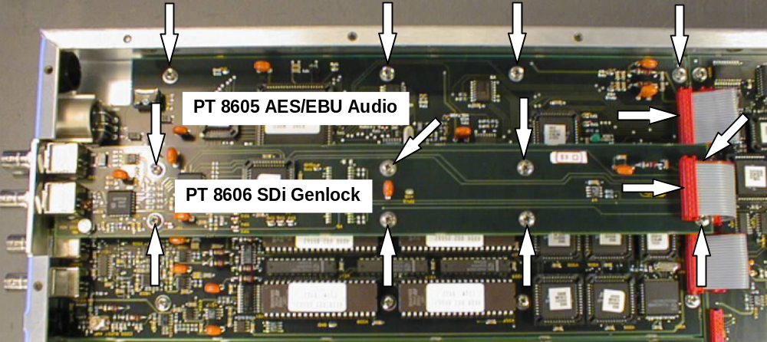
Picture 1.

Picture 1: The positioning of the PT 8605 AES/EBU Audio module in PT 5210 with the PT 8606 SDI Genlock module installed. The positioning of the hexagonal spacers are mounted below the screws fixing the PT 8606 SDI Genlock module.

